THIRD PARTY-LOGISTICS COORDINATOR PICK PACK TO DESPATCH

Once spare request is approved then system will generate the issue .Issue ink will be available . Issue will be assigned to the respective warehouse coordinator.

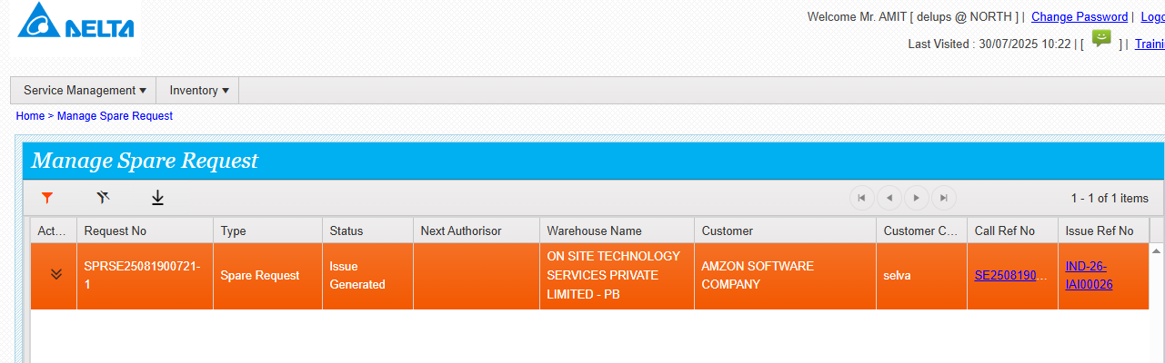

LOGISTICS coordinator do the following steps

URL- <https://mcis.deltaiserve.net/>

1)Type the URL , enter the login credential and do the login

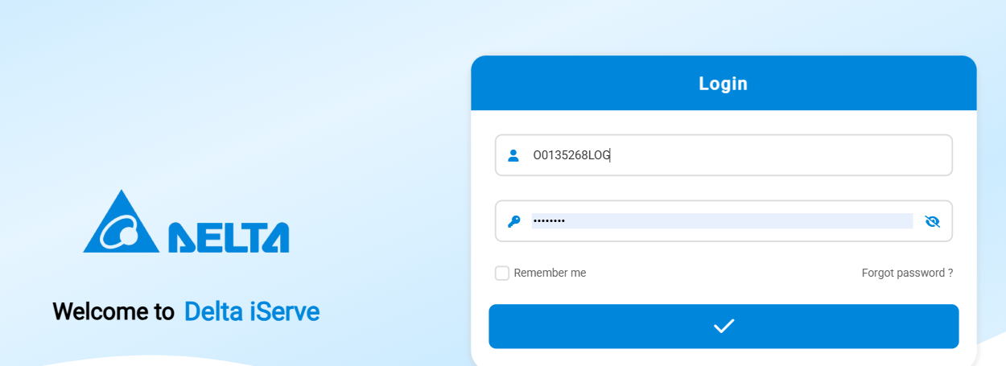

2) Go to inventory issue module and see the assigned issue ticket.

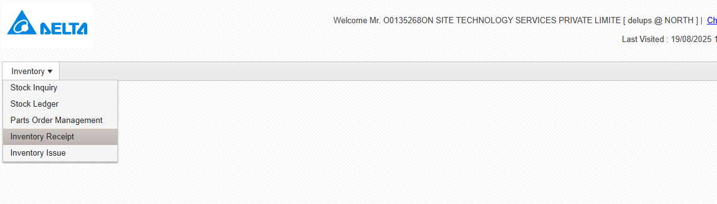

GO to action and click , see the actions available ,

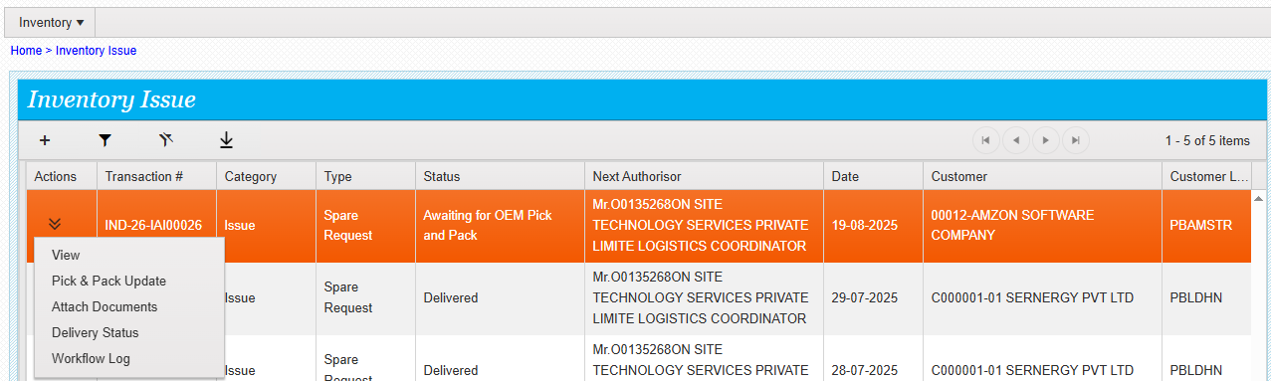

Click on pick pack and update te no of packages , select the serial no /for the serialized part. Update the remarks and submit ,

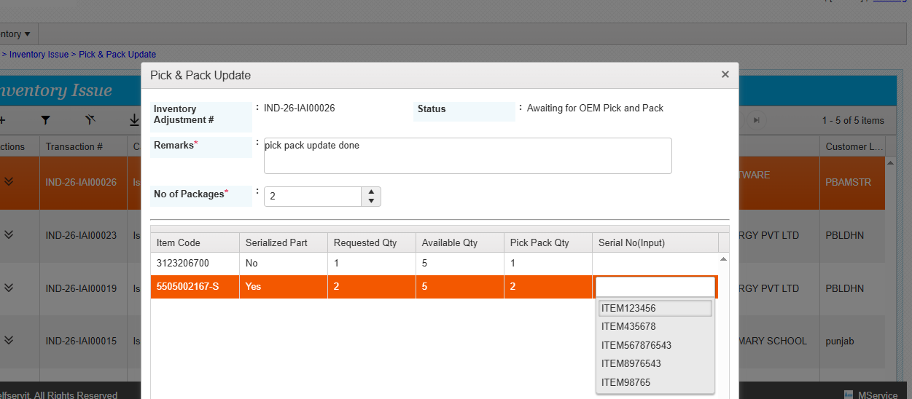

Pick pack done successfully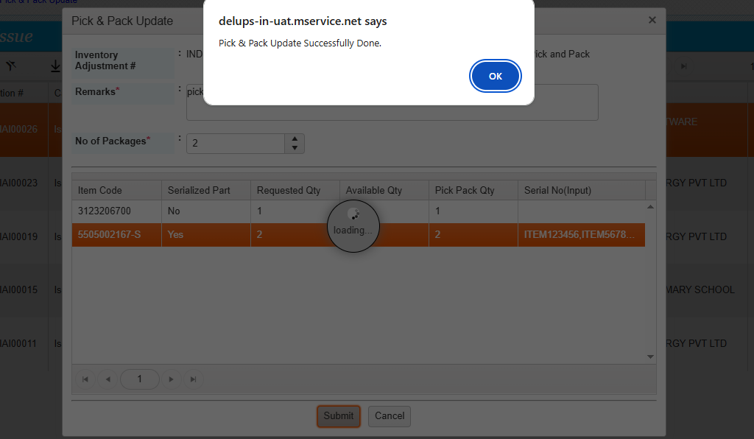

Reversal pick pack is possible /if required logistics coordinator can do it before dispatch update , once dispatch update is done the reversal pick pack is not possible.

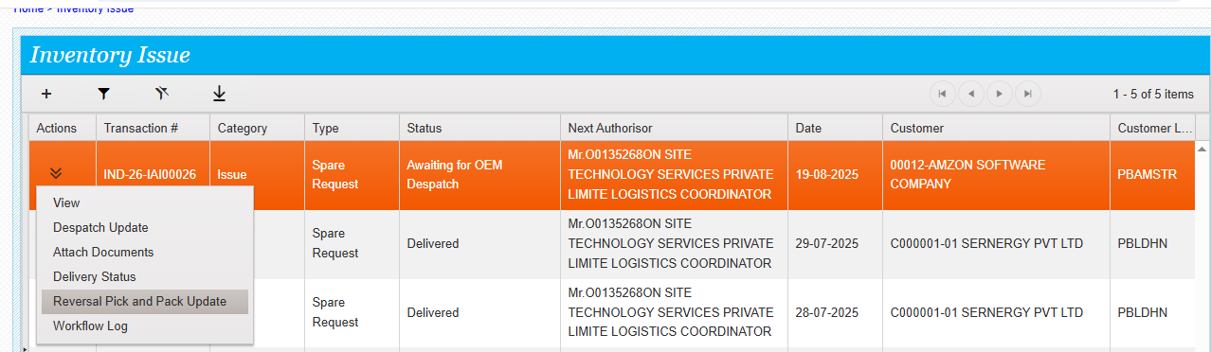

Click on dispatch update

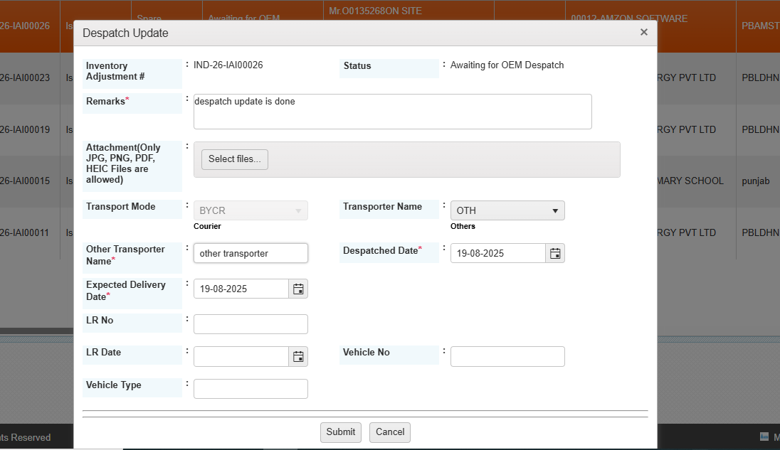

Enter the required details and submit /dispatch update done successfully,

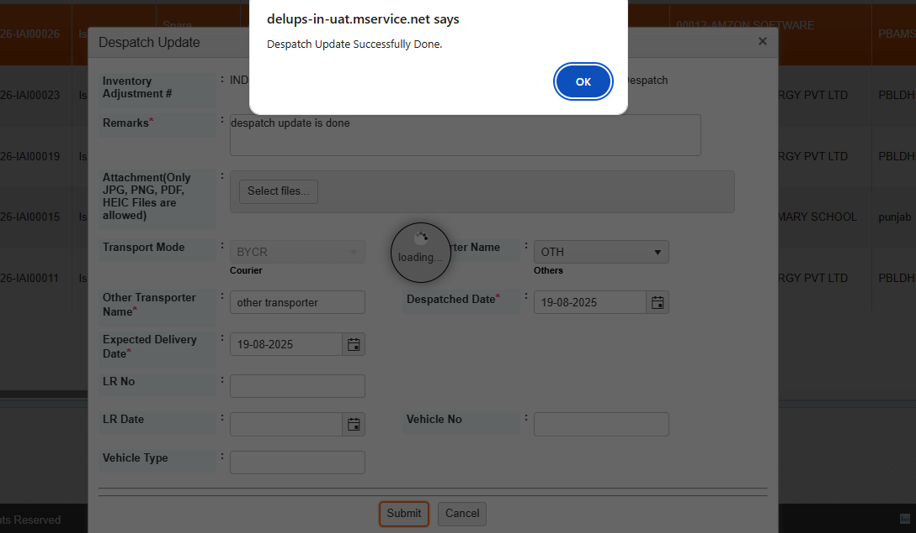

The status of the issue is material despatched,

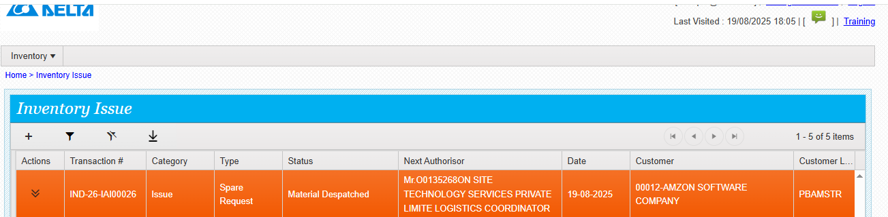

Update delivery status .

